“Our idyllic setting will be yours to customise and create the day you have always dreamed of. We can assist in recommending caterers, marquee suppliers, entertainment and refreshment vendors. Whatever you envisage we can help you create”.
Amanda Benton
Proprietor

The village of Thompson lies within the sprawling Thetford Forest, itself part of the lesser known Norfolk Brecks. While the North Norfolk Coast and the famous Norfolk Broads are the destinations of choice for most tourists to the East of England, the Brecks are one of the hidden gems that are not to be missed.

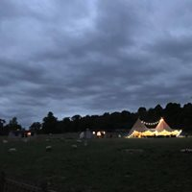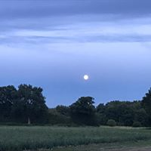
When booking Thompson Hall for your special day we believe you are booking a picturesque, private and unique spot in the amazing Norfolk countryside. Brimming with a vibrant variety of flora and fauna, an unmapped woodland walk is the best way to soak up the atmosphere of this serene woodland and take some amazing pictures for your photo album to remember your magical day.
Our idyllic setting will be yours to customise and create the day you have always dreamed of. We can assist in recommending caterers, marquee suppliers, entertainment and refreshment vendors. Whatever you envisage we can help you create.
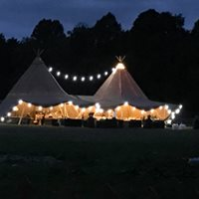
Your wedding party guests that stays at our site will not only have access to our luxurious shepherd huts and our hybrid bell tents but will also have access to our beautiful outdoor spa area with our hot tub and sauna. All accommodation is included in the venue price as well as our quaint cottage that is perfect for the honeymoon couple. We can even cater for the morning after by supplying your party with retreat breakfast hampers to start the day with a full English. Standard or vegetarian option available too.

Your exclusive hire of our venue is as follows…….
Accommodation to sleep 14/18 guests which is
- 3 x Shepherd huts – sleeping 6 in total
- 2 x Hybrid bell tents – sleeping 4 in total ………. (1 used to sign registry for legal requirement)
- Thompson holiday cottage – sleeping 4
(Please be aware that Thompson Holiday cottage is not within the grounds of Thompson Hall but is situated approximately 2 miles away by road)
Raphael’s meadow to hold the function
Portable toilet hired for the occasion (disabled toilets can be hired upon request)
Waste management for removal of all rubbish
Onsite parking for guests
Camping pitches for guests if they so wish
Electric hook up for vendors, bar, band, etc
Access to site for set up and arrangements
Use of the spa area for all night guests (Children excluded)
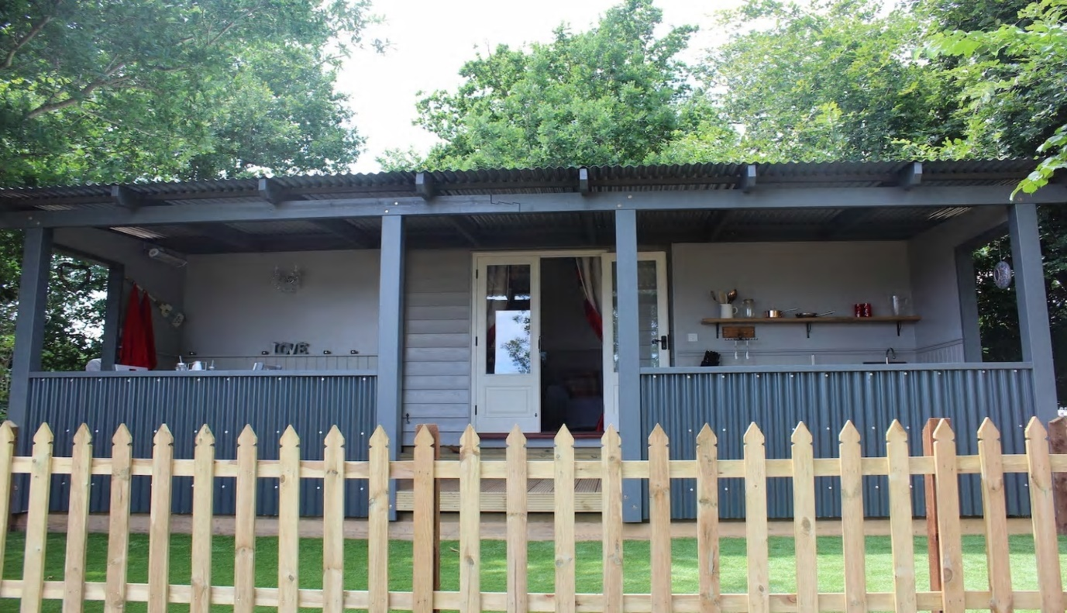
Use of the woodland areas for function photos

It’s Important to read these Terms & Conditions before you Book, please contact us if you have any queries on 01953 488731 or email us at info@thompsonhallretreat.co.uk
The hirer and entire booking party must always take full responsibility for themselves and all children/other guests/external caterers/visitors that come onto site and agree to ensure that these notes are made aware to all:

- At no time may guests/visitors smoke in the shepherd’s huts, Spa area or the hybrid bell tents–please supervise and don’t allow young children to be in the spa. The Gas BBQs and Wood burners must be supervised by an adult. No BBQs be used or stored inside any structure/tent on site. NO open fires or BBQs are permitted.

- Children must always be supervised as the wooded areas are natural & wild and there is a small body of water nearby and the treehouses have steep steps (and may not really be suitable or easy to use – please be mindful & careful)

- The gas fires pits are to be used properly and safely. Please follow the guideline that the last person must make sure it’s extinguished, and that the gas is turned off at the supply before leaving. If it is to be left unattended, please warn other campers. Children must always be supervised, it is a gas fire, and that kneeling around a fire is safer then standing over it when cooking.

- Please no naked flames, Sky lanterns or fireworks these are a fire hazard, particularly to our wooded areas and our stables on site.

- NO glass in the field, Children may play there, sometimes bare foot!

- THR do not supply staff for the event please ensure this is covered by the relevant companies
​
- Please be aware of the emergency routes, Extinguisher locations, Telephone numbers, Meeting points. If there was a fire, please evacuate your tent or hut immediately, leaving your belongings, raise the alarm to passing huts tents and ring the fire bell, meet at the safety point to call the emergency services.

- All guests please note that the areas around the stables and yard area are always out of bounds. please do not go beyond the gate or paddock fencing for your own safety. Anybody found beyond this boundary without being accompanied by a member of staff may be asked to leave the premises

- Strictly no speeding on site we recommend a 5mph limit due to wildlife and uneven tracks. If disabled access is required for weddings and deliveries, please advise of any drop offs and access required

- If having a party or music, this must be arranged with us. Any music or bar must stop/close at the agreed time, age restrictions apply to the bar.
​
- We understand campers and guests may bring their own drinks and food, however we do ask that this is managed responsibly and there is naturally an awareness for other guests and children.

- THR guests and visitors agree to use the whole site peacefully and abide by THR standards of acceptable behaviour, THR is in a quiet, residential area but we do have neighbours and the party are asked to be careful of noise and loud music particularly when leaving

- Only the person hiring, and the stated Guests listed on the Booking Form are allowed on site overnight. Please let us know if you wish for extra guests, or day guests. Additional People staying is great, Campers and guests understand we may have the need and right to enter accommodation to make any agreed repairs, decorations, alterations, deliveries or in case of an emergency

- If you wish to add any day activities that need a private, sectioned off space, please let us know, we charge a small hourly rate to external companies coming in using the space, or if you would like amplified music this must be at the bar area

Arrival/Departure
For Camping arrival from 3pm. (unless otherwise arranged) and we have an 11am check out, if you want a little longer please ask. Please inquire about pitching tents beforehand to ensure all safety guidelines are met

THR hampers and spa packs can be ordered and added to the package for night guests if you so wish. This will be at an additional cost to the person hiring the venue.
​
Cancellation/Deposit
Upon booking a £500 non-refundable deposit will be taken as confirmation of booking. Further payments will be made in accordance with terms agreed with THR. We are happy to accept payment from third parties however it is the sole responsibility of the hirer to ensure full payment is made.

Cancellations received within two months of the booked date will incur 50% of the booking total, within 1 month the full amount of the booking total must be paid.

The descriptions of the location and accommodation of the shepherd huts and cabins are provided in good faith but could sometimes be subject to errors, omissions, prior bookings or withdrawal without notice

If THR are successful in reletting the accommodation after cancellation this amount will be deducted from the cancellation charge and refunded to the hirer of the venue.

Access
To access the site, please park in the car park and walk up the path. For disabled access please drive straight up the drive to park near the carpark and we can assist you. Our toilet facilities and pathways are fine to use with help, but a motorised or manual wheelchair can't get inside the toilets, sorry, we are currently planning to create better facilities

Please inform THR of any loss, damage, or other complaint, Dispute or claim concerning the occupancy of common areas as soon as possible. THR is not liable for any loss, damage, or inconvenience caused by anything beyond its control.

Remember you are glamping, and if it rains, we will honestly try and help you organise some cover on site. It’s important to walk the site and ensure you are happy for your party to take responsibility for themselves and that the maximum liability that may be attributed to THR for occurrences, damages or personal injuries, sustained or transpiring at or around THR during the booking period, shall be limited to the amount advanced

We advise you to take a fully comprehensive, all risks, Travel Insurance and Personal Liability Insurance and thank you for understanding the nature of THR and its surroundings and safety issues and the common areas.

Thank you for your enquiry and we look forward hearing from you
By booking with THR, you acknowledge you have read, understood and accept the terms and conditions here and that we do not accept any liability for any loss, damage, or additional expenses incurred by the named booker, guests or any member of the party regardless of the cause. THR does not accept liability for any injury, death, loss, inconvenience or damage, alteration, delay or cancellation of the booking at all

Health and Safety
All electrical equipment used by the customer must be PAT tested and have up to date labelling and relevant certificates
Licensing
A professionally licensed bar must have proof of the Temporary Events Notice awarded by the local council along with a Personal Licence holder working at the venue
Catering
All catering is to be supplied by the Customer or an external catering company of their choosing. We can offer recommendations or suggestions of reputable caterers if you need help.
Promotional Materials
Unless notified in writing THR reserves the right to use any material shot by guests & professional photographers and to take promotional photos & videos which you agree to being used at any time either online pages and/or through printed media. You also agree to your photographer allowing us to use their photographs (with credit to them) as stated above.
SPA Restrictions
No children allowed in the spa area
Spa is only open to evening Guests unless agreed with THR at time of Booking
All guests must shower before use of hot tub as excessive beauty products and self-tanning products can contaminate water treatment
No electric appliances within 1.5 meters of the spa
No smoking allowed in the spa area
No glass allowed in the spa area
Only 6 people at any one time to use the hot tub
Damages
Any damage to property or equipment at THR will be chargeable to you and as such a breakages deposit is required. You may either give us a cheque or your debit card details as a guarantee for us to ensure we have a way of recouping any costs liable as result of any damage to property. We reserve the right to charge for any unreasonable damages and breakages but not without discussing this with you first and giving you a breakdown of any costs.
A walk of the site will take place (with the hirer) to check for damage before and after event.

The accommodation when hiring Thompson Hall is as follows……

Our hybrid bell tents | The fire fly | Sleeps 2
 | The Dragonfly | Sleeps 2

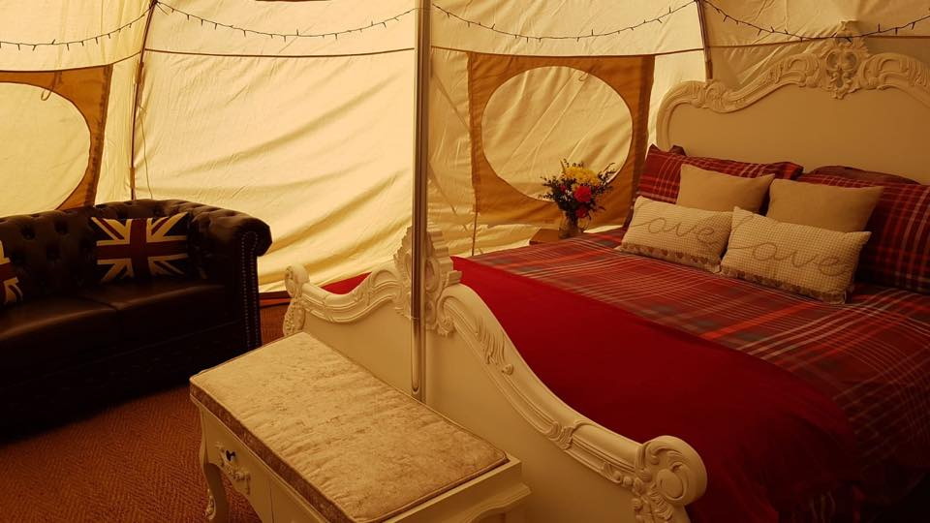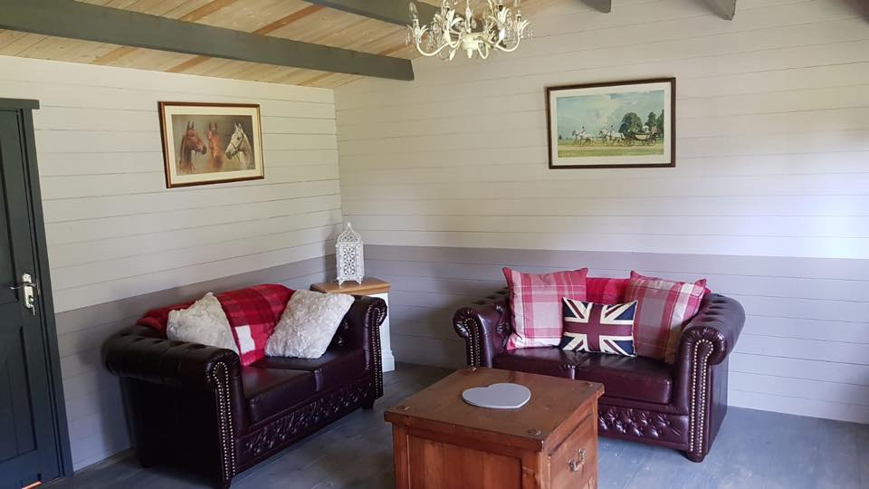

Our Shepherds huts | The Hartley Hut | Sleeps 2
 | The Bishy Hut | Sleeps 2
 | The Whoa stop | Sleeps 2
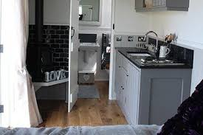
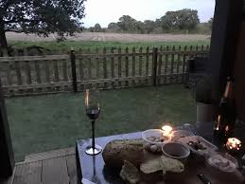

These are on site and accessible at the venue itself. All have bathrooms and kitchen facilities if they are required.
Our holiday cottage |  | 1 college road |  | Sleeps 4
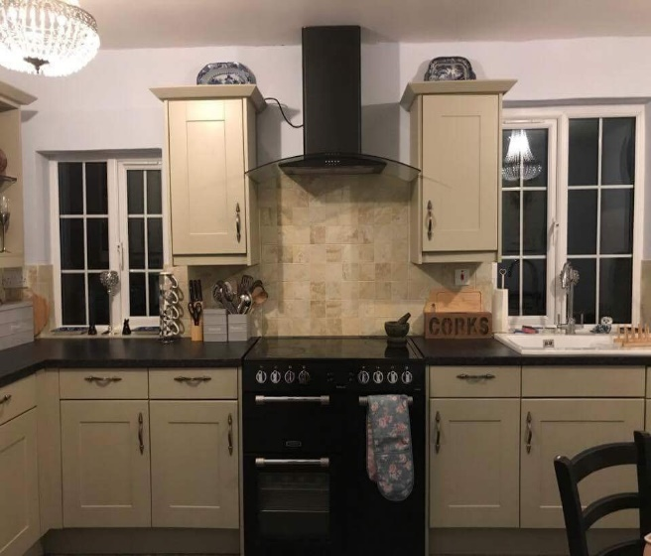
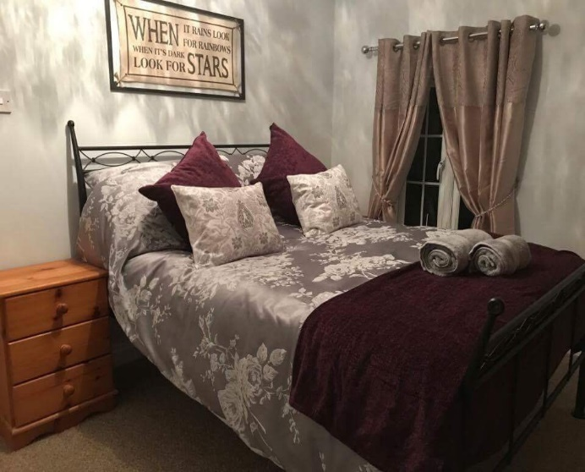
(Please be aware that Thompson Holiday cottage is not within the grounds of Thompson Hall but is situated approximately 1 mile away by road)

Venue breakdown is listed below
3 x Shepherd huts – sleeping 6 in total
2 x Hybrid bell tents – sleeping 4 in total
Thompson holiday cottage – sleeping 4
Waste management
Camping pitches for guests if they so wish
Portable toilet hired for the occasion
Electric hook up for vendors, bar, band, etc
Camping pitches for guests if they so wish
Raphael’s meadow and entire retreat

total | £3500.00

Breakfast hampers are available for you and your guests at an additional cost see website for details visit www.thompsonhallretreat.co.uk for details under the “Retreat Boxes” Link

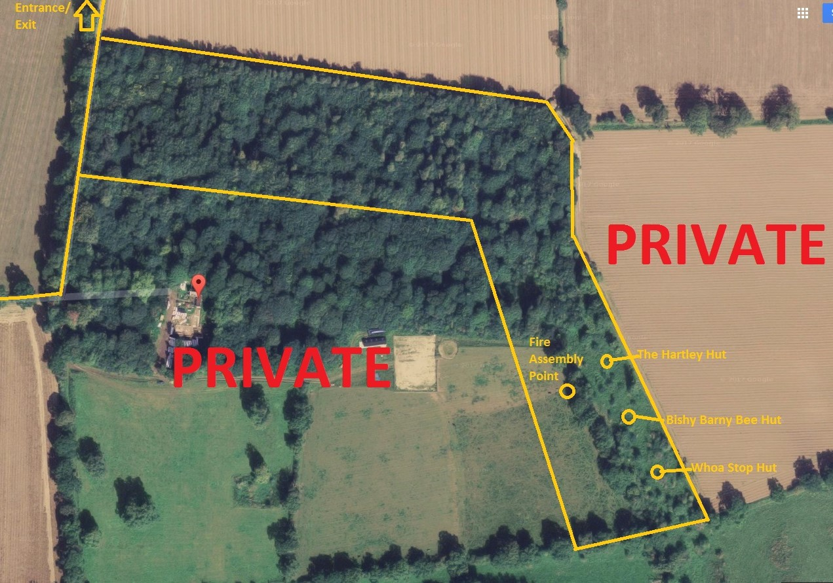

All areas within the yellow marked boundary (Raphael’s meadow and wooded area) are accessible to guests and party members. Please be aware that the stables, Horses and Thompson hall are out of bounds unless prior permission is received when booking.

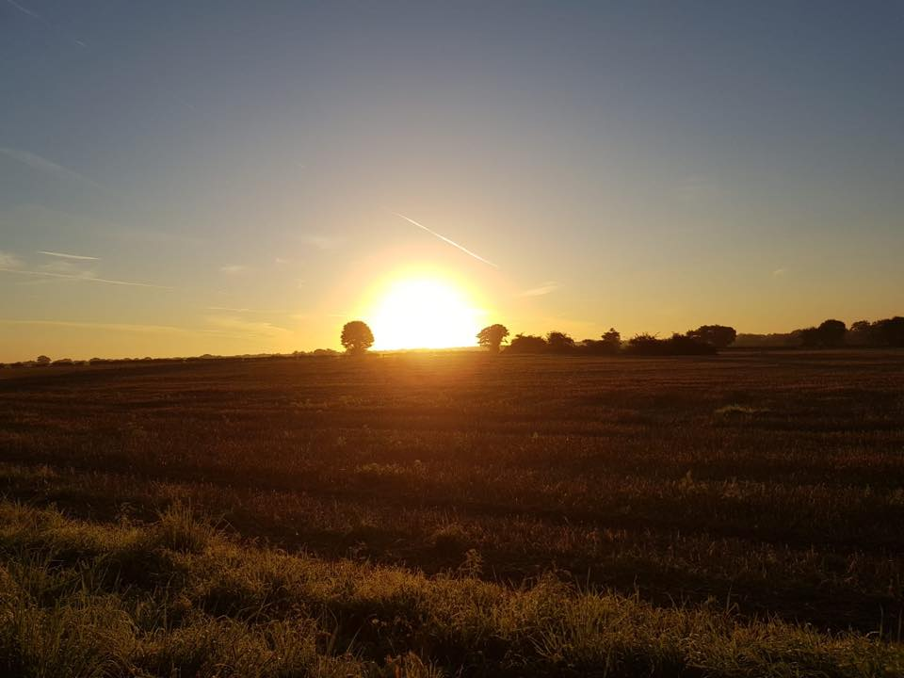
Recommended Caterers
Pie Central, email - info@piecentral.co.uk or Phone 07508855873
Florentine, Email - hello@florentina-events.com or Phone 07723363597
Nomadi Pizza, Email - info@pizza-party.co.uk or Phone 07901536709
Spitfire Hog Roasts, Email - gavin@Spitfirehogroasts or Phone 07958761027
Station Smokehouse, Email - events@thestationsmokehouse.com or Phone 01603910123
Recommended marquee’s
Magical Events, Email - party@magicaleventsltd.co.uk or Phone 01362637483
Morton’s Event, Phone 01692538928
Grice & Foster, Email - info@gricefostereventhire.co.uk or Phone 01328853018
Recommended Bakers, Bars, Photographers, Florists
P.Wilson Photography, Email - info@patrickwatsonphotography.co.uk or Phone 01603702067
B’s Bakes, Email - Enquiries@beesBakesNorfolk.co.uk or Phone 07530853593
East Coast Bars, Email - info@eastcoastbars.co.uk or Phone 07725978986
La Belle Fleur, Email - info@labellefleur.co.uk or Phone 01245322422
Recommended entertainment
Charlie Sadd, Email - https://www.charliesadd.co.uk/contact
Capture lounge, Email - capture.lounge@outlook.com or Phone 07585006647
Magic Dave Gillespie, Phone 07825266262
Josh Maddocks Magic, Email - https://www.joshmaddocks.com/book-now

